tODD – Temporal Odour Delivery Device
Inventory – 4 channel device
Part | Part # | Quantity
Valve Manifold
Valve Manifold | INMA0601340B (Lee) | 1
M/P VHS Valve | INKX0514750A (Lee) | 4
Standard Manifold Port | IKTX0322170A (Lee) | 4
Manifold Plug | IKTX0322190A (Lee) | 4
Tubing + Connectors
Standard tubing 5cm | TMZA3202010Z (Lee) | 4
Standard tubing 10cm | TUTC3216905L (Lee) | 4
Male-Male 062 MINSTAC | TMUA3205950Z (Lee) | 4
MINSTAC 062 Screen | INMX0350000A (Lee) | 5
Spike-and-Hold Driver
PCB Header (4 way) | 483-8483 (RS) | 1
Crimp Connector (2 way) | 679-5363 (RS) | 1
Crimp Connector (4 way) | 296-4956 (RS) | 1
PCB Header (2 way) | 483-8461 (RS) | 1
Crimp terminals | 467-598 (RS) | 1
Circuit board | Custom component
Diode 1N4005 | 628-9142 (RS) | 3
Linear voltage regulator | 761-3537 (RS) | 1
NPN transistor | 761-3701 (RS) | 2
Timer NE555P | 221-5535 (RS) | 1
DIL Socket Mount | 813-115 (RS) | 1
Potentiometer | 522-0300 (RS) | 1
Zener Diode | 813-3925 (RS) | 1
NPN Darlington Transistor | 790-5397 (RS) | 1
PNP Darlington Transistor | 790-5393 (RS) | 1
Capacitor 101 | 652-9759 (RS) | +
Capacitor 104 | 108-2700 (RS) | +
Capacitor 103 | 653-0260 (RS) | +
Capacitor 473 | 721-5280 (RS) | +
Resistor Kit | 156-2565 (RS) | 1
Enclosures | 281-6863 (RS) | 4
Power Supply / Interface
Capacitor 101 | 652-9759 (RS) | 1
Capacitor 10uF | 117-035 (RS) | 1
PCB Header (4 way) | 483-8483 (RS) | 1
Crimp Connector (2 way) | 679-5363 (RS) | 1
Crimp Connector (4 way) | 296-4956 (RS) | 1
PCB Header (2 way) | 483-8461 (RS) | 1
Linear regulator 3.3V | 661-6737 (RS) | 1
Enclosure | 281-6784 (RS) | 1
Odour Block
Odour block | Custom component | 1
15ml Vial (PTFE Lined) | 27003 (Sigma) | 1 (Pack of 100)
Flow Controller | 721-3512 (RS) | 4
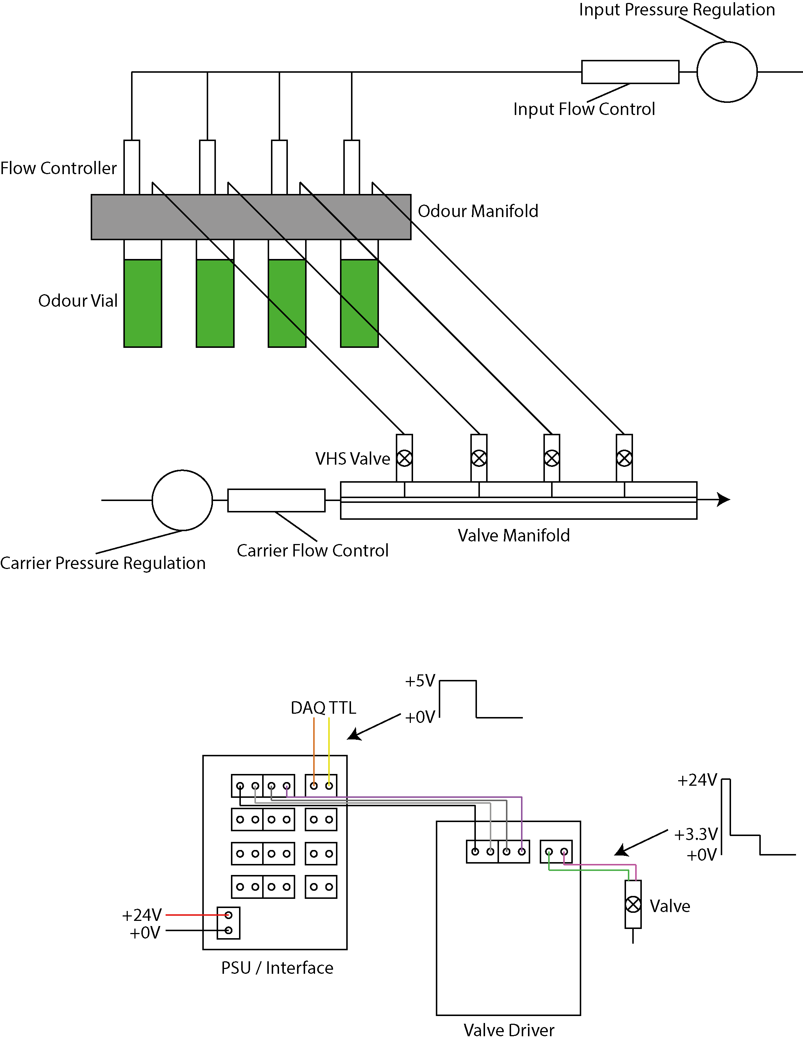

tODD – Summary
tODD is designed to be a compact, scalable olfactometer capable of create dynamic odour stimuli with good temporal bandwidth. Temporal responsiveness is achieved by a) using high-speed injection valves to release odours and b) minimising dead volume within the path that odour must travel to release.
Release of odours from individual odour lines is controlled by its associated injection valve. Because of the speed of these valves, amplitude of release can be entirely controlled at the level of the valve by pulse-width modulating the valve as it opens. For example, to release the maximum amount of odour, the valve is simply opened and closed for the desired stimulus time. To produce 50% amplitude of signal, the valve is opened and closed at e.g. 500Hz with 50% pulse duty for the desired stimulus time. Controlling the intensity of odour release at the level of the valve, rather than attempting to quickly adjust air dilution of the odour with e.g. digital flow controllers increases the temporal responsiveness of the system.
Because of the high-speed of cycle, the valves must be controlled with a spike-and-hold driver to avoid overheating. When the driver is triggered with a standard 5V pulse, the spike and hold driver converts this to a short (ms length) 24V pulse to open the valve, and then drops the voltage to ~3.3V which keeps the valve in the open state.
tODD can produce odour pulses (50% duty) with ~100% signal fidelity at up to 50Hz. Odour signal modulation is still observed at higher frequencies but with lower fidelity. The main factors affecting signal fidelity and stability are a) choice of input/carrier flow and pressure settings; b) length of tubing carrying odour and c) volume of odour in the vials. Generally a good strategy is to keep pressure on the odour vials as low as possible while still maintaining an observable output signal as this reduces the pressure change in the vial when the valve opens creating a more stable signal. Tubing length should be kept to a minimum as long tubing filters the signal and reduces signal fidelity.
Software
tODD is operated by directly controlling the valves through the drivers with standard 5V TTL pulses via e.g. a NI board with DIO. Any software that can control a DAQ board with DIO can therefore be used to drive the tODD, e.g. LabView.
PulseBoy is a custom GUI tool for generating sequences of complex pulse trains that is designed to be flexible and modular. Individual sets of pulses are generated in the software by assigning a widget (specific set of parameters and parsing logic) to each valve to be controlled. PulseBoy then combines the information for each valve and parses it into the digital output required to drive the valves. Users can build a sequence of different pulse trains, which PulseBoy then runs sequentially to produce e.g. a set of stimuli for an ephys experiment. Users can define their own widgets for valve control that can then be integrated into the software.
PulseBoy and its dependencies can be found at: https://github.com/RoboDoig
